Project Design Phase-I
Solution Architecture

Date | 1 November 2026
Team ID | Individual Project
Project Name | Electric Vehicle Market Performance & Insights
Maximum Marks | 4 Marks

Solution Architecture:
Solution architecture is a complex process – with many sub-processes – that bridges the gap between business problems and technology solutions. Its goals are to:
- Find the best tech solution to solve existing business problems.
- Describe the structure, characteristics, behavior, and other aspects of the software to project stakeholders.
- Define features, development phases, and solution requirements.
- Provide specifications according to which the solution is defined, managed, and delivered.

Sample Solution Architecture Diagram:
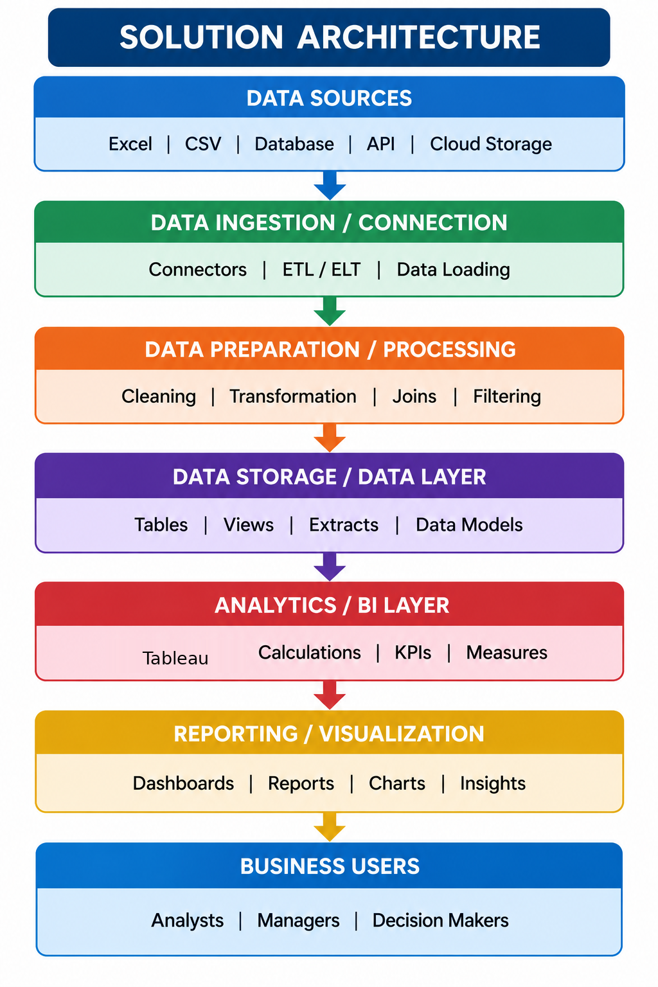

Component Description Table

Component Name | Description / Role in Architecture | Technology Used
Dataset | Provides EV market records such as vehicle ID, manufacturer, price, vehicle category, range, and battery capacity. | CSV dataset
Data Preparation | Cleans data, checks missing values, standardizes data types, and prepares fields for analysis. | Tableau / Python
Data Source & Analysis | Uses the prepared EV dataset directly in Tableau to organize records, create calculated fields, apply filters, and summarize market trends. No SQL database or SQL queries are used. | Tableau Data Source / Extract
Visualization & Dashboard | Displays trends, comparisons, KPIs, and interactive insights for users. | Tableau; Flask

